Probleme Backtracing
1
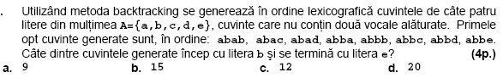
2
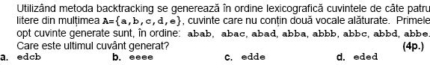
3
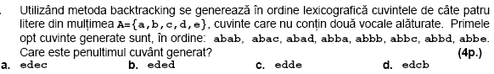
4
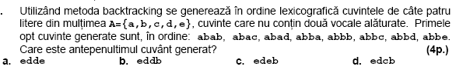
5
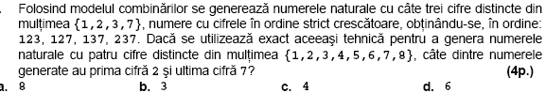
6

7
8

9

10
